**Bank Loan Report Query Document**

1. **Bank Loan Report | Summary**

**KPI’s**

**Total Loan Applications**

select COUNT(id) as Total_Loan_Applications from bank_loan_data;



**Month-to-Date (MTD) Loan Applications**

select COUNT(id) as MTD_Total_Loan_Applications from bank_loan_data

where month(issue_date) = 12 and YEAR(issue_date) = 2021;



**PMTD Loan Applications**

select COUNT(id) as PMTD_Total_Loan_Applications from bank_loan_data

where month(issue_date) = 11 and YEAR(issue_date) = 2021;



**Month-over-Month (MoM)**

**(Month-to-Date (MTD) Loan Applications - PMTD Loan Applications)**

**4314 – 4035 = 279**

**Total Funded Amount**

select SUM(loan_amount) as Total_Funded_Amount from bank_loan_data;



**MTD Total Funded Amount**

select SUM(loan_amount) as MTD_Total_Funded_Amount from bank_loan_data

WHERE MONTH(issue_date) = 12



**PMTD Total Funded Amount**

select SUM(loan_amount) as PMTD_Total_Funded_Amount from bank_loan_data

WHERE MONTH(issue_date) = 11



**Month-over-Month (MoM)**

**(Month-to-Date (MTD) Total Funded Amount**

**- PMTD Total Funded Amount)**

**53981425 – 47754825 = 62,26,600**

**Total Amount Received**

select SUM(total_payment) as Total_Amount_Received from bank_loan_data;



**Month-to-Date (MTD) Total Amount Received**

select SUM(total_payment) as MTD_Total_Amount_Received from bank_loan_data

WHERE MONTH(issue_date) = 12 AND YEAR(issue_date) = 2021;



**PMTD Total Amount Received**

select SUM(total_payment) as PMTD_Total_Amount_Received from bank_loan_data

WHERE MONTH(issue_date) = 11 AND YEAR(issue_date) = 2021;



**Month-over-month (MoM) changes.**

**Average Interest Rate**

SELECT ROUND(AVG(int_rate),4)*100 as Avg_intrest_rate from bank_loan_data;



**MTD Average Interest Rate**

SELECT ROUND(AVG(int_rate),4)*100 as MTD_Avg_intrest_rate from bank_loan_data

WHERE MONTH(issue_date) = 12 AND YEAR(issue_date) = 2021;



**PMTD Average Interest Rate**

SELECT ROUND(AVG(int_rate),4)*100 as PMTD_Avg_intrest_rate from bank_loan_data

WHERE MONTH(issue_date) = 11 AND YEAR(issue_date) = 2021;



**Average Debt-to-Income Ratio (DTI)**

SELECT Round(AVG(dti),4)*100 as Avg_DTI FROM bank_loan_data;



**MTD Average Debt-to-Income Ratio (DTI)**

SELECT Round(AVG(dti),4)*100 as MTD_Avg_DTI FROM bank_loan_data

WHERE MONTH(issue_date) = 12 AND YEAR(issue_date) = 2021;



**PMTD Average Debt-to-Income Ratio (DTI)**

SELECT Round(AVG(dti),4)*100 as PMTD_Avg_DTI FROM bank_loan_data

WHERE MONTH(issue_date) = 11 AND YEAR(issue_date) = 2021;



**GOOD LOAN ISSUED**

**Good Loan Percentage**

select

(COUNT(case when loan_status = 'Fully Paid' or loan_status = 'Current' then id end)*100.0)

/

COUNT(id) as Good_Loan_Percentage

from bank_loan_data;



**Good Loan Application**

select COUNT(id) as Good_Loan_Applications from bank_loan_data

where loan_status = 'Fully Paid' or loan_status = 'Current';



**Good Loan Funded Amount**

select sum(loan_amount) as Good_Loan_Funded_Amount from bank_loan_data

where loan_status = 'Fully Paid' or loan_status = 'Current';



**Good Loan Total Received Amount**

select sum(total_payment) as Good_Loan_Total_Recived_Amount from bank_loan_data

where loan_status = 'Fully Paid' or loan_status = 'Current';



**BAD LOAN ISSUED**

**Bad Loan Percentage**

select

(count(case when loan_status = 'Charged off' then id end)*100.0)

/

count(id) as Bad_Loan_Parcentage

from bank_loan_data



**Bad Loan Applications**

select count(id) as Bad_Loan_Applications from bank_loan_data

where loan_status = 'Charged off';



**Bad Loan Funded Amount**

select sum(loan_amount) as Bad_Loan_Funded_Amount from bank_loan_data

where loan_status = 'Charged off';



**Bad Loan Total Received Amount**

select sum(total_payment) as bad_Loan_Total_Recived_Amount from bank_loan_data

where loan_status = 'Charged off';

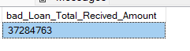

**Loan Status Grid View**

SELECT

loan_status,

COUNT(id) AS LoanCount,

SUM(total_payment) AS Total_Amount_Received,

SUM(loan_amount) AS Total_Funded_Amount,

AVG(int_rate * 100) AS Interest_Rate,

AVG(dti * 100) AS DTI

FROM

bank_loan_data

GROUP BY

loan_status

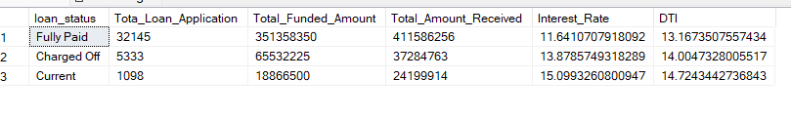

SELECT

loan_status,

SUM(loan_amount) as MTD_Total_Funded_Amount,

sum(total_payment) as MTD_Total_Amount_Received

from bank_loan_data

where MONTH(issue_date) = 12 and year(issue_date) = 2021

group by loan_status

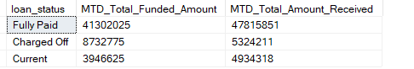

1. **BANK LOAN REPORT | OVERVIEW**

**MONTH**

select

MONTH(issue_date) as Month_number,

DATENAME(MONTH,issue_date) as Month_name,

count(id) as Total_Loan_Application,

sum(loan_amount) as Total_Loan_Amount,

sum(total_payment) as Total_Amount_Recived

from bank_loan_data

group by MONTH(issue_date),

DATENAME(MONTH,issue_date)

order by MONTH(issue_date);

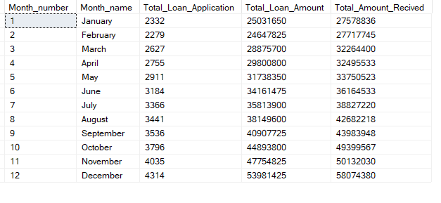

**STATE**

SELECT

address_state AS State,

COUNT(id) AS Total_Loan_Applications,

SUM(loan_amount) AS Total_Funded_Amount,

SUM(total_payment) AS Total_Amount_Received

FROM bank_loan_data

GROUP BY address_state

ORDER BY address_state

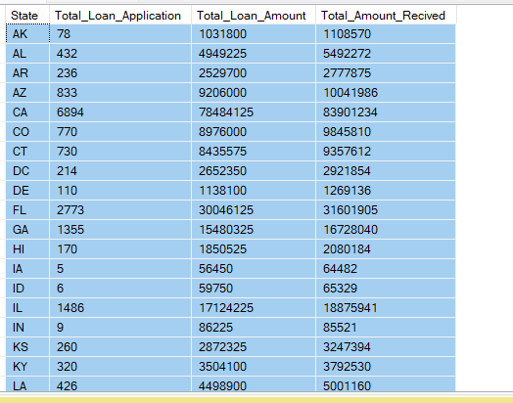

**TERM**

select

term as Term,

count(id) as Total_Loan_Application,

sum(loan_amount) as Total_Loan_Amount,

sum(total_payment) as Total_Amount_Recived

from bank_loan_data

group by term

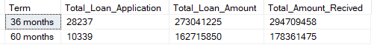

**EMPLOYEE LENGTH**

select

emp_length as Employee_Length,

count(id) as Total_Loan_Application,

sum(loan_amount) as Total_Loan_Amount,

sum(total_payment) as Total_Amount_Recived

from bank_loan_data

group by emp_length

order by emp_length;

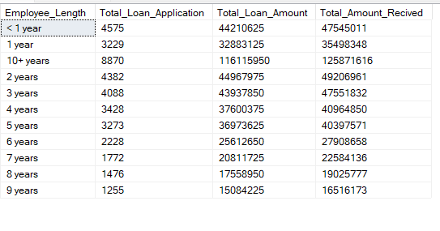

**PURPOSE**

select

purpose as Purpose,

count(id) as Total_Loan_Application,

sum(loan_amount) as Total_Loan_Amount,

sum(total_payment) as Total_Amount_Recived

from bank_loan_data

group by purpose

order by purpose;

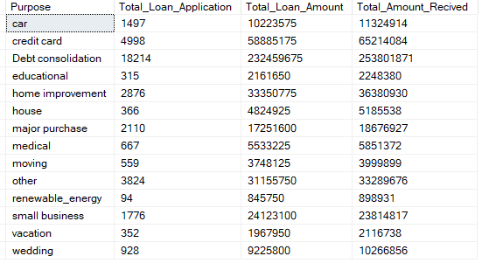

**HOME OWNERSHIP**

select

home_ownership as Home_Ownership,

count(id) as Total_Loan_Application,

sum(loan_amount) as Total_Loan_Amount,

sum(total_payment) as Total_Amount_Recived

from bank_loan_data

group by home_ownership

order by home_ownership;

